An Introduction to phylogeny constructions

Introduction: basic workflow
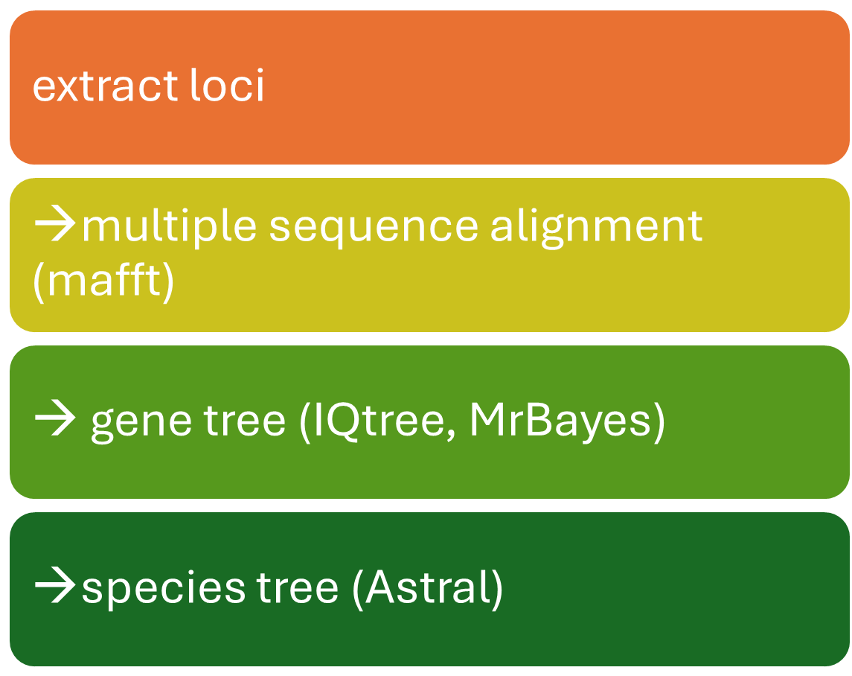
function RUN_mafft {

INFILE=$1
OUTFILE=$2
mafft --maxiterate 10000 $INFILE > $OUTFILE
}

function iqtree_per_gene {

INFILE=$1
iqtree -s $INFILE -bb 1000 -redo -safe
}

OK if you just need the code for multiple sequence alignment and IQTree, this is it.
function run_astral_all_genes {

INDIR=$1
OUTDIR=$2
NAME=$3

echo 'running astral with all genes'
cat $INDIR/*treefile > $OUTDIR/$NAME.in.treefile
#create astral phylogeny with selected genes
java -jar $astral -i $OUTDIR/$NAME.in.treefile -o $OUTDIR/$NAME.out.treefile 2>out.log
echo -e '\n\n\nDONE running astral with all genes\n\n\n'

}

Different Algorithms

Parsimony (Maximum Parsimony, MP)
Goodness…
you don’t want to use this…
just a bad assumption
as biology and evolution are rarely parsimonious

Principle:
The best tree is the one that requires the fewest evolutionary changes—i.e. the most parsimonious explanation for the data.
How it works:
- Compares possible tree topologies.
- Counts the number of character-state changes (mutations) needed to explain the data for each tree.
- The tree with the smallest total number of changes is chosen.
Assumptions:
- Evolution is parsimonious—i.e., simpler (fewer changes) is more likely.
- No explicit model of sequence evolution (non-parametric).
Strengths:
- Conceptually simple and fast.
- Works with both molecular and morphological data.
Weaknesses:
- Can be misled by homoplasy (e.g., convergent evolution).
- Does not account for variable rates of evolution or multiple substitutions at the same site.
- Less reliable for deep or fast-evolving lineages.
Typical use:
Morphological data or exploratory analyses where model assumptions are hard to justify.

Maximum Likelihood (ML)
Principle:
ML chooses the tree that has the highest probability of producing the observed sequence data, given a specific model of molecular evolution (e.g., substitution rates, base frequencies).
How it works:
- Each possible tree topology is evaluated.
- The likelihood of the observed data given that tree (and the model) is calculated.
- The tree with the maximum likelihood is selected.
Assumptions:
- Requires an explicit model of sequence evolution (record that for method section).
- Assumes sites evolve independently according to that model.
Strengths:
- Statistically rigorous and generally accurate for large datasets.
- Incorporates complex models of evolution (e.g., variable rates among sites).
- Provides branch lengths and support values (e.g., bootstrap or likelihood ratios).
Weaknesses:
- Computationally intensive (especially for large datasets).
- Sensitive to model choice—wrong models can bias results.
Typical use:
Single-gene or concatenated multi-gene datasets with relatively low gene tree conflict.

ASTRAL (Accurate Species TRee ALgorithm)
Principle:
ASTRAL is a coalescent-based method that estimates the species tree from a set of gene trees, accounting for incomplete lineage sorting (ILS).
How it works:
- Takes pre-estimated gene trees as input (from ML, for example).
- Searches for the species tree that maximises the number of shared quartets (four-taxon subtrees) across gene trees.
- Uses the multi-species coalescent model, which models gene tree discordance due to ancestral population processes.
Assumptions:
- Discordance among gene trees arises mainly from ILS (not hybridisation, HGT, or gene duplication/loss).
- Gene trees are reasonably accurate.
Strengths:
- Handles gene tree conflict statistically—better than concatenation when ILS is present.
- Scales efficiently to large genomic datasets.
- Provides statistical support (local posterior probabilities).
Weaknesses:
- Depends on the quality of input gene trees.
- Assumes ILS is the only source of discordance—other processes (e.g. introgression) can mislead it.
- Does not use raw sequence data directly.
Typical use:
Genome-scale, multi-locus datasets (e.g., phylogenomics) where different genes have conflicting histories.

Summary
Feature | Maximum Likelihood | Parsimony | ASTRAL
Type | Model-based (IQTree) | Non-parametric | Coalescent-based
Input | Sequence or character data | Sequence or character data | Set of gene trees
Goal | Find tree with highest data likelihood | Find tree with fewest changes | Infer species tree accounting for ILS
Accounts for rate variation? | ✅ Yes | ❌ No | ✅ Indirectly (through gene trees)
Handles gene tree discordance? | ❌ Not inherently | ❌ No | ✅ Yes
Computational cost | High | Low | Moderate
Best for | Accurate single-gene trees | Morphological/short sequences | Large multi-gene datasets

Gene tree & Species Tree

Gene tree: IQTREE
A great tool for generating gene trees: IQtree
IQ-TREE (“Intelligent Quick Tree”) is a fast, versatile, and statistically rigorous program for phylogenetic inference using Maximum Likelihood (ML).
It is developed by Bui Quang Minh and colleagues and is now one of the most widely used tools for molecular phylogenetics and phylogenomics.
It’s the successor of PhyML and RAxML in many workflows — combining the speed of heuristics with advanced statistical features such as automatic model selection, ultrafast bootstrapping, and partitioned analysis.

- Automatic model selection
- Maximum likelihood
- Bootstrap support
- Computationally efficient
- Output treefiles compatible with ASTRAL for downstream species tree analysis

Core Algorithm and Functionality
a. Maximum Likelihood (ML) Tree Search
- IQ-TREE estimates the phylogeny that maximises the likelihood of observing the input sequence alignment under a specified model of evolution.
- It uses an efficient hill-climbing search:
  - Starts from an initial tree (e.g. via neighbour-joining or random trees).
  - Iteratively applies nearest-neighbour interchanges (NNI) and other topological rearrangements.
  - Retains changes that improve the log-likelihood until convergence.
- It’s optimised in C++ and uses stochastic perturbation to escape local optima — giving it an edge over older tools.
b. Site-Heterogeneous Models
IQ-TREE supports a very wide range of substitution models:
- Nucleotide: JC, HKY, GTR, etc.
- Amino acid: WAG, JTT, LG, etc.
- Codon models (e.g. MG94, GY94).
- Mixture models (e.g. LG4X, PMSF, C10–C60 profiles).
- Rate heterogeneity: Γ-distribution (+G), proportion of invariant sites (+I), or FreeRate models (+R).
These can be combined flexibly (e.g. GTR+F+R5).

ModelFinder: Automatic Model Selection
One of IQ-TREE’s most powerful features is ModelFinder, integrated directly into the workflow.
a. What it does:
ModelFinder tests a large set of candidate substitution models and selects the one that best fits the data according to an information criterion:
- AIC, AICc, BIC, or Corrected BIC (BICc).
It evaluates:
- Substitution matrices (e.g., GTR, HKY, etc.)
- Base or amino-acid frequencies (empirical vs estimated)
- Rate heterogeneity models (+I, +G, +R)
- Partition-specific models (if applicable)
b. ModelFinder+ (IQ-TREE 2)
Introduced in IQ-TREE 2, ModelFinder+ efficiently handles thousands of partitions and can test linked or unlinked models across genes.
c. Advantages
- Very fast (uses approximate likelihoods for initial ranking).
- Automatically suggests the best-fit model per partition or overall dataset.
- Can test mixture models and FreeRate models, often yielding better fits than traditional discrete Γ models.

Bootstrap and Branch Support Methods
IQ-TREE provides several advanced methods to measure branch support (statistical confidence in inferred splits):
a. Ultrafast Bootstrap Approximation (UFBoot)
- A fast approximation to traditional bootstrap resampling.
- 1000 ultrafast replicates can be computed in minutes rather than hours.
- Corrected versions (UFBoot2) reduce biases by including a bootstrap correlation test to detect model violations.
HAVEN’T USED THEM PERSONALLY BUT APPARENTLY AVAILABLE:
b. SH-aLRT (Shimodaira–Hasegawa approximate likelihood ratio test)
- Provides an alternative support measure based on local likelihood comparison among rearranged trees.
- Reported as SH-aLRT %, often combined with UFBoot support (e.g. “95/100”).
c. Transfer Bootstrap Expectation (TBE)
- A newer measure that is more stable for large trees and avoids overconfidence in deep branches.

Performance and Speed
IQ-TREE is extremely efficient due to:
- Stochastic tree search heuristics (jumping out of local optima).
- Multithreading and vectorised computations.
- Optimised numerical likelihood functions.
- Checkpointing for long runs and resuming interrupted analyses.
It generally runs faster than RAxML or PhyML while producing trees of equal or higher likelihood.

Output and Interpretation
Typical outputs include:
- .treefile – best ML tree with branch lengths and support.
- .log – log-likelihoods, model details, convergence.
- .iqtree – summary including model chosen, AIC/BIC scores.
- .ufboot – bootstrap trees.
- .model.gz – full list of models tested by ModelFinder.
Support values can be visualised in FigTree or iTOL, often as SH-aLRT / UFBoot pairs on branches.

Advantages (Pros)
Category | Advantages
Speed | Very fast tree inference and bootstrapping (UFBoot).
Accuracy | Statistically rigorous ML inference with mixture models.
Model Selection | Integrated ModelFinder gives data-driven model choice.
Flexibility | Handles DNA, protein, codon, and partitioned datasets.
Ease of use | Simple CLI syntax; clear logs and documentation.
Support metrics | SH-aLRT, UFBoot2, TBE, and concordance factors.
Parallelisation | Efficient use of multi-core CPUs.
Reproducibility | Stores seeds, parameters, and checkpoints.

Limitations (Cons)
Category | Limitation
Model dependency | As a model-based method, results can be biased if the wrong model is chosen.
ILS and hybridisation | ML assumes a single species tree (that’s why concatenation is not good often); does not account for incomplete lineage sorting or reticulation (use ASTRAL for that).
Gene tree error | For phylogenomics, separate gene tree estimation can introduce errors.
Memory use | Large genome-scale alignments may require high RAM.
Recombination | Assumes a single bifurcating history — not suitable for recombining sequences.

ASTRAL methods: Resolving Species Trees (optional readings)

Conceptual overview
In phylogenomics, different genes often yield different gene trees because of processes such as:
- Incomplete Lineage Sorting (ILS)
- Gene duplication/loss
- Horizontal gene transfer
- Hybridisation
ASTRAL is designed to infer a species tree that best explains a collection of gene trees under the multi-species coalescent (MSC) model, which explicitly accounts for ILS — but not for the other processes.
Core assumption: Multi-Species Coalescent (MSC)
The MSC model assumes:
- Each gene has its own tree (gene tree) that may differ from the species tree.
- Discordance between gene trees arises from random coalescent events in the ancestral population (ILS).
- Within each ancestral branch, gene lineages coalesce randomly with probabilities determined by population size and branch length (in coalescent units).
Important parameters:
- Effective population size (Nₑ)
- Branch lengths (t) measured in coalescent units (t = time / 2Nₑ)
Under the MSC, the probability of a given gene tree topology is a function of the species tree topology and its branch lengths.

Mathematical foundation of ASTRAL
Input:
- A set of k unrooted gene trees, typically inferred using ML or Bayesian methods.
- Taxon coverage may be incomplete (ASTRAL handles missing taxa gracefully).
Output:
- The species tree (unrooted) that is most congruent with the set of gene trees.

Step 1: Represent trees by quartets
A quartet is an unrooted tree with four taxa.
For four taxa (A, B, C, D), there are three possible unrooted topologies:
- AB|CD
- AC|BD
- AD|BC
Each gene tree can be decomposed into a set of quartets.
If a gene tree contains all four taxa, it contributes one quartet topology for that four-taxon subset.

Step 2: Define the ASTRAL objective function
ASTRAL seeks the species tree S* that maximises the number of shared quartet topologies between the gene trees and S*.
So, ASTRAL finds the tree whose implied quartets agree most often with those observed in the gene trees.
This objective function is NP-hard (time comsuming), but ASTRAL uses efficient heuristics to solve it exactly for smaller datasets and approximately for large ones.

Step 3: Dynamic programming solution
ASTRAL uses a dynamic programming algorithm to build the optimal species tree:
- It considers bipartitions (splits) of taxa into two subsets.
- For each possible bipartition, it computes a score based on the number of supporting quartets across gene trees.
- The algorithm recursively combines the best-supported splits to assemble the species tree with maximum total quartet support.
This is much faster than exhaustively checking every possible topology.

Statistical support in ASTRAL
ASTRAL provides branch support values, derived from quartet frequencies and posterior-like probabilities.

(a) Local Posterior Probability (LPP)
Introduced in ASTRAL-III, the LPP estimates the probability that a given branch (split) in the species tree is correct, given the distribution of quartet topologies around that branch.
For each internal branch:
- Consider the four subsets of taxa defined by that branch.
- Count how many gene trees support each of the three possible quartets.
- Compute the posterior probability that the species tree’s quartet topology is the true one, assuming:
  - All gene trees are independent.
  - Quartet frequencies follow a multinomial distribution with probabilities given by the MSC model.

Interpretation:
- LPP ≈ 1 → strong support for that branch
- LPP ≈ 0.33 → no signal (quartets evenly split)
- LPP < 0.33 → possible conflict or error

(b) Quartet Support (QS)
A simpler measure:
For a given branch, the quartet support is the proportion of gene trees (or quartets) that agree with the species tree’s split.
ASTRAL sometimes reports:
- QS+, QS−, and QS0 for concordant, discordant, and uninformative quartets, respectively.
Intuitive example
Imagine three genes (G₁, G₂, G₃) from species A, B, and C:
- G₁ supports AB|C
- G₂ supports AC|B
- G₃ supports AB|C
The majority of gene quartets support AB|C → ASTRAL infers that the species tree is AB|C, but also computes how strongly (LPP, QS) that split is supported.

Model assumptions and limitations
Category | Assumption | Consequence if violated
Evolutionary process | Discordance due to ILS (multi-species coalescent) | Hybridisation or gene duplication/loss can mislead results
Gene trees | Estimated accurately and independently | Errors in gene tree inference propagate to species tree
Taxon sampling | Independent across genes | Biased sampling can reduce accuracy
Sequence data | No horizontal gene transfer | Reticulate evolution not captured

Comparison to concatenation
Why ASTRAL is simply so much better
Feature | Concatenation (ML on supermatrix) | ASTRAL
Assumes a single tree for all genes | ✅ Yes | ❌ No
Handles ILS explicitly | ❌ No | ✅ Yes
Works on gene trees | ❌ (raw alignments) | ✅ (gene trees only)
Statistically consistent under MSC | ❌ | ✅
Sensitive to gene tree estimation error | Moderate | High (depends on input quality)

Summary
Aspect | Description
Method type | Summary-coalescent, quartet-based
Input | Set of gene trees
Output | Unrooted species tree
Model | Multi-species coalescent (ILS only)
Objective | Maximise agreement in quartets between gene trees and species tree
Support values | Local Posterior Probability (LPP), Quartet Support (QS)
Strengths | Scalable, statistically consistent under ILS
Weaknesses | Sensitive to gene tree error; ignores hybridisation/duplication

Random Coalescent Event (optional readings)

Basic idea: tracing lineages backwards in time
Imagine you sample several gene copies (alleles) from different individuals or species.
If you trace those gene copies backward in time, at some point two of them will share a common ancestor — they will coalesce.
This point in time is a coalescent event.

What “random” means here
In population genetics, coalescent theory treats the ancestry of genes as a stochastic (random) process driven by population size and time.
Each pair of lineages has a certain probability per unit time of coalescing, depending on the effective population size (Nₑ).

That’s why coalescence is described as random:
we can’t predict the exact time or which pair of lineages will coalesce first — only the probability distribution.
Extending to multiple lineages
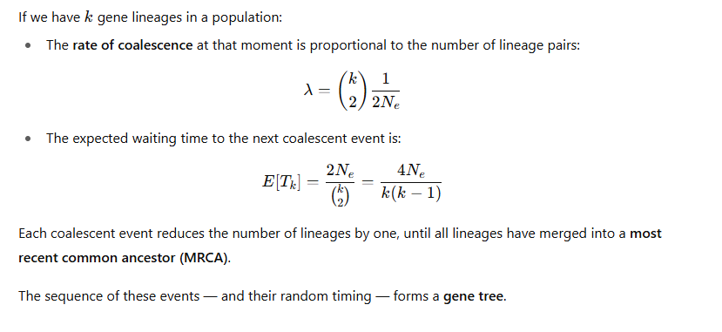

Random coalescence and species trees
Now consider multiple species diverging according to a species tree.
When we trace gene lineages backward:
- Inside each ancestral population (branch of the species tree), gene lineages from descendant species may or may not coalesce before the next speciation event.
- Whether they do is determined randomly by the coalescent process, depending on the branch length (in coalescent units).
If two speciation events happen close together in time, there may not be enough time for coalescence to occur in the ancestor — leading to incomplete lineage sorting (ILS).
Thus, different genes may show different topologies — all because of the random timing of coalescent events.

Probability of random coalescence within a branch

📊 7. In the Multi-Species Coalescent model
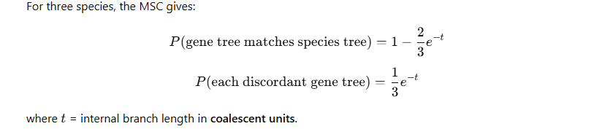Thus, even if all species diverged according to one species tree, gene trees are random draws from this probability distribution — i.e. random coalescent events lead to variable gene histories.

Summary
Concept | Meaning
Coalescent event | Two ancestral gene lineages merge into a common ancestor
Random | Occurs probabilistically, governed by population size and time
Rate | 1/(2Ne)1 / (2Nₑ)1/(2Ne​) per lineage pair
Distribution | Exponential waiting times
Implication for species trees | Random timing causes gene tree discordance (ILS)
In ASTRAL | This stochastic variation in gene trees is modelled by the MSC, which ASTRAL approximates via quartet frequencies

Would you like me to show a small diagrammatic explanation (with 3–4 species) illustrating how random coalescent events lead to different gene trees even under the same species tree? It makes the concept much more intuitive.

Phylogeny Visualization: FigTree
FigTree is a graphical viewer and editor for phylogenetic trees, developed by Andrew Rambaut (University of Edinburgh), who also co-developed BEAST.
It’s a lightweight (that’s why we can still use it in CropDiversity), Java-based program widely used for displaying, annotating, and exporting publication-quality phylogenetic trees.
FigTree doesn’t infer phylogenies itself — it visualises and manipulates tree files (usually in Newick or Nexus format) that are produced by programs like IQ-TREE, BEAST, MrBayes, or RAxML.

Main Purposes
- Visualise and edit phylogenetic trees.
- Display branch lengths, node support values, and annotations.
- Root, reroot, or reorient trees interactively.
- Change branch scaling and layout (rectangular, radial, polar).
- Export high-resolution figures for reports or publications.

Input and Output Formats
Input:
- Newick (.tre or .tree) — the simplest and most common tree format.
- Nexus (.nex) — often from BEAST, may include posterior probabilities, divergence times, or metadata.
Output:
- Vector and bitmap images: PDF, SVG, PNG, JPEG.
- Editable tree data: Nexus, Newick (after re-rooting or editing).

Tree Display Styles
FigTree offers multiple display modes, each emphasising different aspects of tree topology or branch length information.
Display Style | Description | When to use
Original Tree | Shows the tree exactly as inferred — branch lengths are proportional to the evolutionary distances (e.g., substitutions per site). | For ML or Bayesian trees where branch length conveys genetic divergence.
Equal (or "Ultrametric/Equal Branch Lengths") | All tips are equally distant from the root, regardless of branch length. | For visual clarity or when branch length information is unreliable.
Cladogram | Displays topology only — all branches have arbitrary length. | To emphasise relationships rather than distances.
Proportional | Branch lengths proportional to another attribute (e.g., time, number of substitutions, posterior support). | For time-calibrated trees (BEAST) or comparative visualisation.
Let’s unpack each transformation further.

Original Tree
- Uses actual branch lengths from the input file (e.g., expected number of substitutions per site).
- If the tree is ultrametric (as in BEAST), tip heights align automatically; if not, tips may end at different distances from the root.
- Best for showing evolutionary rates or distances.

Equal (Ultrametric)
- Forces all terminal taxa (tips) to align vertically.
- Ignores actual branch lengths and replaces them with equal distances.
- Useful when:
  - The inferred tree isn’t ultrametric but you want a clean visual comparison.
  - You want to highlight topology only, not rate variation.

Cladogram
- A simplified topological tree.
- Branch lengths are arbitrary, typically drawn to fit the display window.
- All internal nodes are positioned equally between the root and tips.
- Excellent for displaying only evolutionary relationships without any measure of distance.

Proportional
Well I found these info online but so far I haven’t found a way to change/figure out what proportion it is
- Scales branch lengths to a user-defined variable or annotation (e.g., divergence time, posterior mean, number of substitutions).
- FigTree can extract numerical annotations (often in BEAST .trees files, e.g. height, posterior, or rate) and visualise them by length or colour.
Example:
- Branch length ∝ “height_95%HPD” → time-calibrated confidence intervals.
- Branch thickness ∝ “posterior” → support proportional to visual width.

Tree Orientation and Layout Options
FigTree provides several layout orientations:
Layout | Description
Rectangular | Standard left-to-right (or top-down) layout; most common for publication figures.
Circular / Radial | Tree radiates from the centre — good for large trees.
Polar | Can be unrooted! Alternative to circular layout that emphasises divergence times.
Phylogram vs. Cladogram toggle | Switch between proportional and equal branch lengths.
You can also flip nodes or order descendants to control the arrangement of clades.

Ordering and Rerooting Nodes

(a) Ordering Nodes
You can reorder sister clades to make the tree visually clearer:
- Order nodes by:
  - Increasing or decreasing node age
  - Manual flipping (click and drag).
Reordering doesn’t change the topology; it only changes the visual layout.

(b) Rerooting
Rerooting allows you to define a new root:
- Click on a branch and select “Reroot”.
- Common for rooting an unrooted ML tree on an outgroup.
- Tip labels and branch lengths automatically adjust relative to the new root.

Scale and Axis Features
(a) Scale Bar
- Displays a scale bar showing the units of branch length.
- In ML trees: usually substitutions per site.
- In BEAST trees: time (e.g., millions of years) if calibrated.
- Can be rescaled manually for readability.
(b) Axis Display
- Option to show a time axis (for ultrametric trees) across the top or side.
- Useful for visualising divergence times and fossil calibrations.
(c) Log-scale or Custom Transformations
- For some datasets (e.g. molecular clocks with large variance), FigTree allows log-scaling of branch lengths to compress long branches.

Annotating Trees
FigTree supports various visual annotations:
Element | Description
Tip labels | Display or hide species names, format font, rotate, align.
Node labels | Display bootstrap values, posterior probabilities, or other annotations.
Branch labels | Display numeric data stored on branches (e.g. substitutions, rates).
Colour coding | Colour branches or labels based on categorical or numeric variables (e.g., clade, posterior).
Node shapes | Circles or bars representing metadata values (e.g., sample size, time).
Annotations can be extracted automatically from BEAST or IQ-TREE outputs (e.g., “support”, “posterior”, “rate”, “height”).

Exporting Figures
You can export publication-quality trees:
- Vector graphics: PDF, SVG (editable in Adobe Illustrator, Inkscape).
- Bitmap images: PNG, JPEG (for quick inclusion in slides).
- Transparent background option available.
- Control over font embedding, scaling, and resolution (DPI).

Strengths and Limitations
Strengths | Limitations
User-friendly GUI for non-programmers | No command-line mode (unsuitable for batch automation)
Supports most standard formats (Newick, Nexus) | Can struggle with very large trees (>10,000 taxa)
Flexible tree transformations (original, equal, proportional) | Limited editing of underlying data (can’t recalculate ML values)
Integrates well with BEAST and IQ-TREE outputs | Primarily designed for visualisation, not analysis
Publication-quality export options | Static (no 3D or interactive web visualisation)

Case2: Extract best hits using outfmt 6: LOCI DETECTION
A more recent request I got this week concerns the moss genus Andreaea:


Question
We got a set of loci sequences and genome assemblies of Andreaea species from online databases.
Now we want to identify and extract the same loci from the assemblies and add them to the phylogeny we are building for Andreaea
How will we design the database? What will you use as the query vs database?
(there are 389 loci to look at. So this is a task best done with array or a for loop. For our purpose, we will look at just one of these loci
THE LOCI: $HOME/projects/rbge/zedchen/workshop/Blast/L288.Andreaea.Target.names.fa
THE GENOME: $HOME/projects/rbge/zedchen/workshop/Blast/A_rothii_chromosome.fasta
How do the query look like? How might we choose the query sequence?

Download from online database: ENA
The genome is from DToL Project and put on ENA:
https://www.ebi.ac.uk/ena/browser/view/GCA_965644345.1
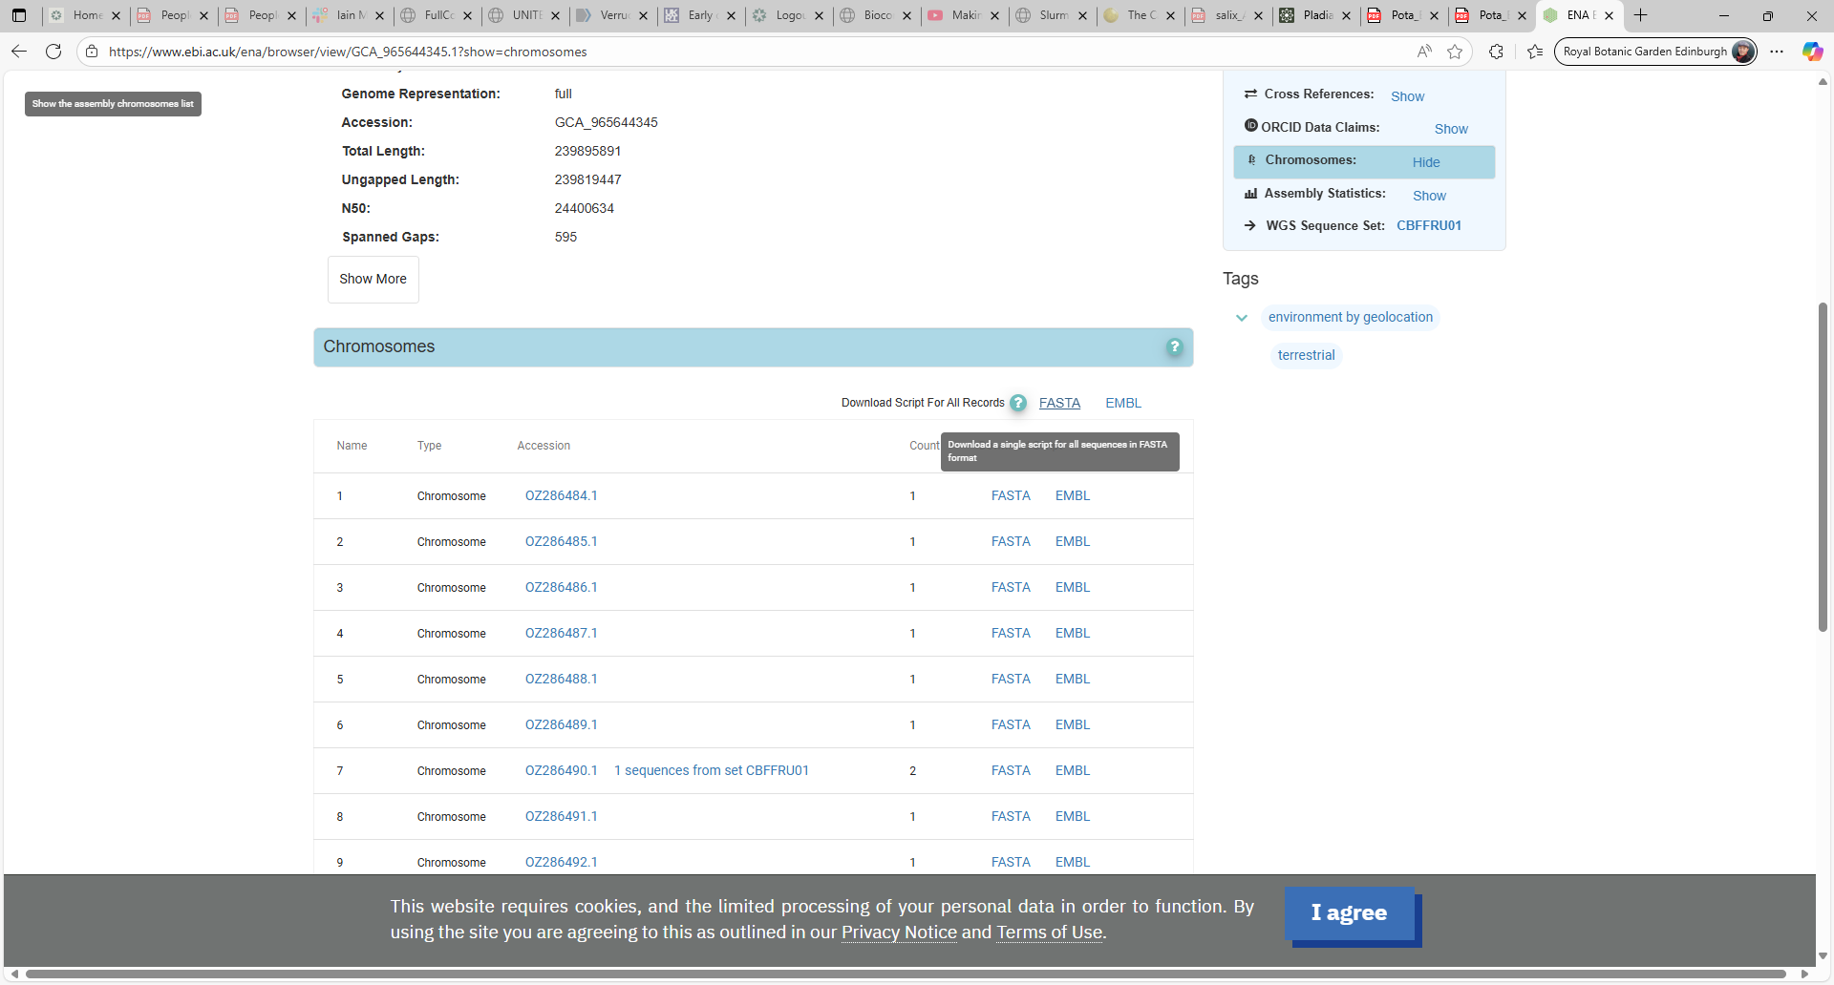
get the wget commands:

You then end up with something like this, which you can add to your script to download all chromosomes and keep good record:
wget https://www.ebi.ac.uk/ena/browser/api/fasta/OZ286484.1 -O - >> GCA_965644345-chromosomes.fasta
wget https://www.ebi.ac.uk/ena/browser/api/fasta/OZ286485.1 -O - >> GCA_965644345-chromosomes.fasta
wget https://www.ebi.ac.uk/ena/browser/api/fasta/OZ286486.1 -O - >> GCA_965644345-chromosomes.fasta
……

for instance I would organise the download task for each species into a part of the script:

function download_ENA {

OUTDIR=$1
SPECIES=$2
START=$3
END=$4
CHROM_ACC=$5
OUTFILE=${OUTDIR}/${SPECIES}_chromosome.fasta
# Only download if file doesn't exist or is empty
if [ ! -f $OUTFILE ] || [ ! -s $OUTFILE ]; then
for i in $(seq $START $END); do
wget https://www.ebi.ac.uk/ena/browser/api/fasta/${CHROM_ACC}${i}.1 -O - >> $OUTFILE
done
else
echo "dataset already downloaded $OUTFILE, skipping..."
fi
}
#now actually use the function
download_ENA ${RESULT1} A_rothii 84 96 OZ2864 GCA_965644345
download_ENA ${RESULT1} A_nivalis 11 21 OZ2813 GCA_965637445
download_ENA ${RESULT1} A_mutabilis 12 23 OZ2862 GCA_965644055
download_ENA ${RESULT1} A_hookeri 24 34 OZ2464 GCA_965231225
#process_sp_ENA ${RESULT1} ${RESULT2} A_frigida 592 604 OZ286 GCA_965644415 #all found
you will need to design it differently if you are using different database, such as SRA or NCBI etc.
but the take home is
- it is a good idea to make something reusable (a function)
- it is good to keep record of how and where you got your data

build your own database and Blast
now we can use the genome assembly as a database and the loci sequences as queries to detect the loci in our new Andreaea species:
what did you notice about the blast output of L288? How many hits does each sequence get?
Can we sort the output in a sensible way?

Extract the loci for A. rothii
Well, not quite, as it requires some python scripting, but at least you will know how to do it theoretically:
On which chromosome can you find the loci?
The coordinate?
What data format is the chromosome? How can we access it and manipulate the sequence?
BioPython…
Presume we got the loci from A. rothii, now we can add it back to the set of loci we have and rerun and phylogeny building program (IQtree etc.)
What’s missing? Outgroups?

And beyond
Remember we often have hundreds of loci to process
That’s when scripting become useful: for loop or parallelizing
It really speeds up the task when you’re doing the same operation for all the inputs

Conclusion & Next Steps
Parsimony represents the simplest historical framework: it seeks the tree that minimises the number of evolutionary changes. While conceptually intuitive and fast, it assumes evolution proceeds in the simplest possible way, an assumption rarely true in molecular evolution.
Maximum Likelihood (ML) methods, implemented efficiently in tools like IQ-TREE, use explicit statistical models of sequence evolution to identify the tree most likely to produce the observed data.
ASTRAL addresses precisely that issue. It estimates a species tree from a collection of gene trees, using the multi-species coalescent model to account for stochastic variation in gene histories.
Together, ML-based and coalescent-based frameworks form the core of modern phylogenomics:
- IQ-TREE provides fast, model-aware gene tree estimation with strong support metrics.
- ASTRAL synthesises those gene trees into a coherent species-level phylogeny, capturing the stochastic nature of lineage sorting.
To interpret and present results, FigTree remains an indispensable tool. It allows intuitive visualisation, annotation, and export of phylogenetic trees in different layouts.
Finally, the practical workflow—from downloading genomes, building local databases, identifying homologous loci via BLAST, and integrating them into phylogenetic pipelines—illustrates how reproducible scripting and data management underpin modern biodiversity genomics.
The key take-home message is that phylogeny building is no longer a single algorithmic task, but a reproducible, multi-step process linking data acquisition, model selection, tree inference, and visual interpretation.

